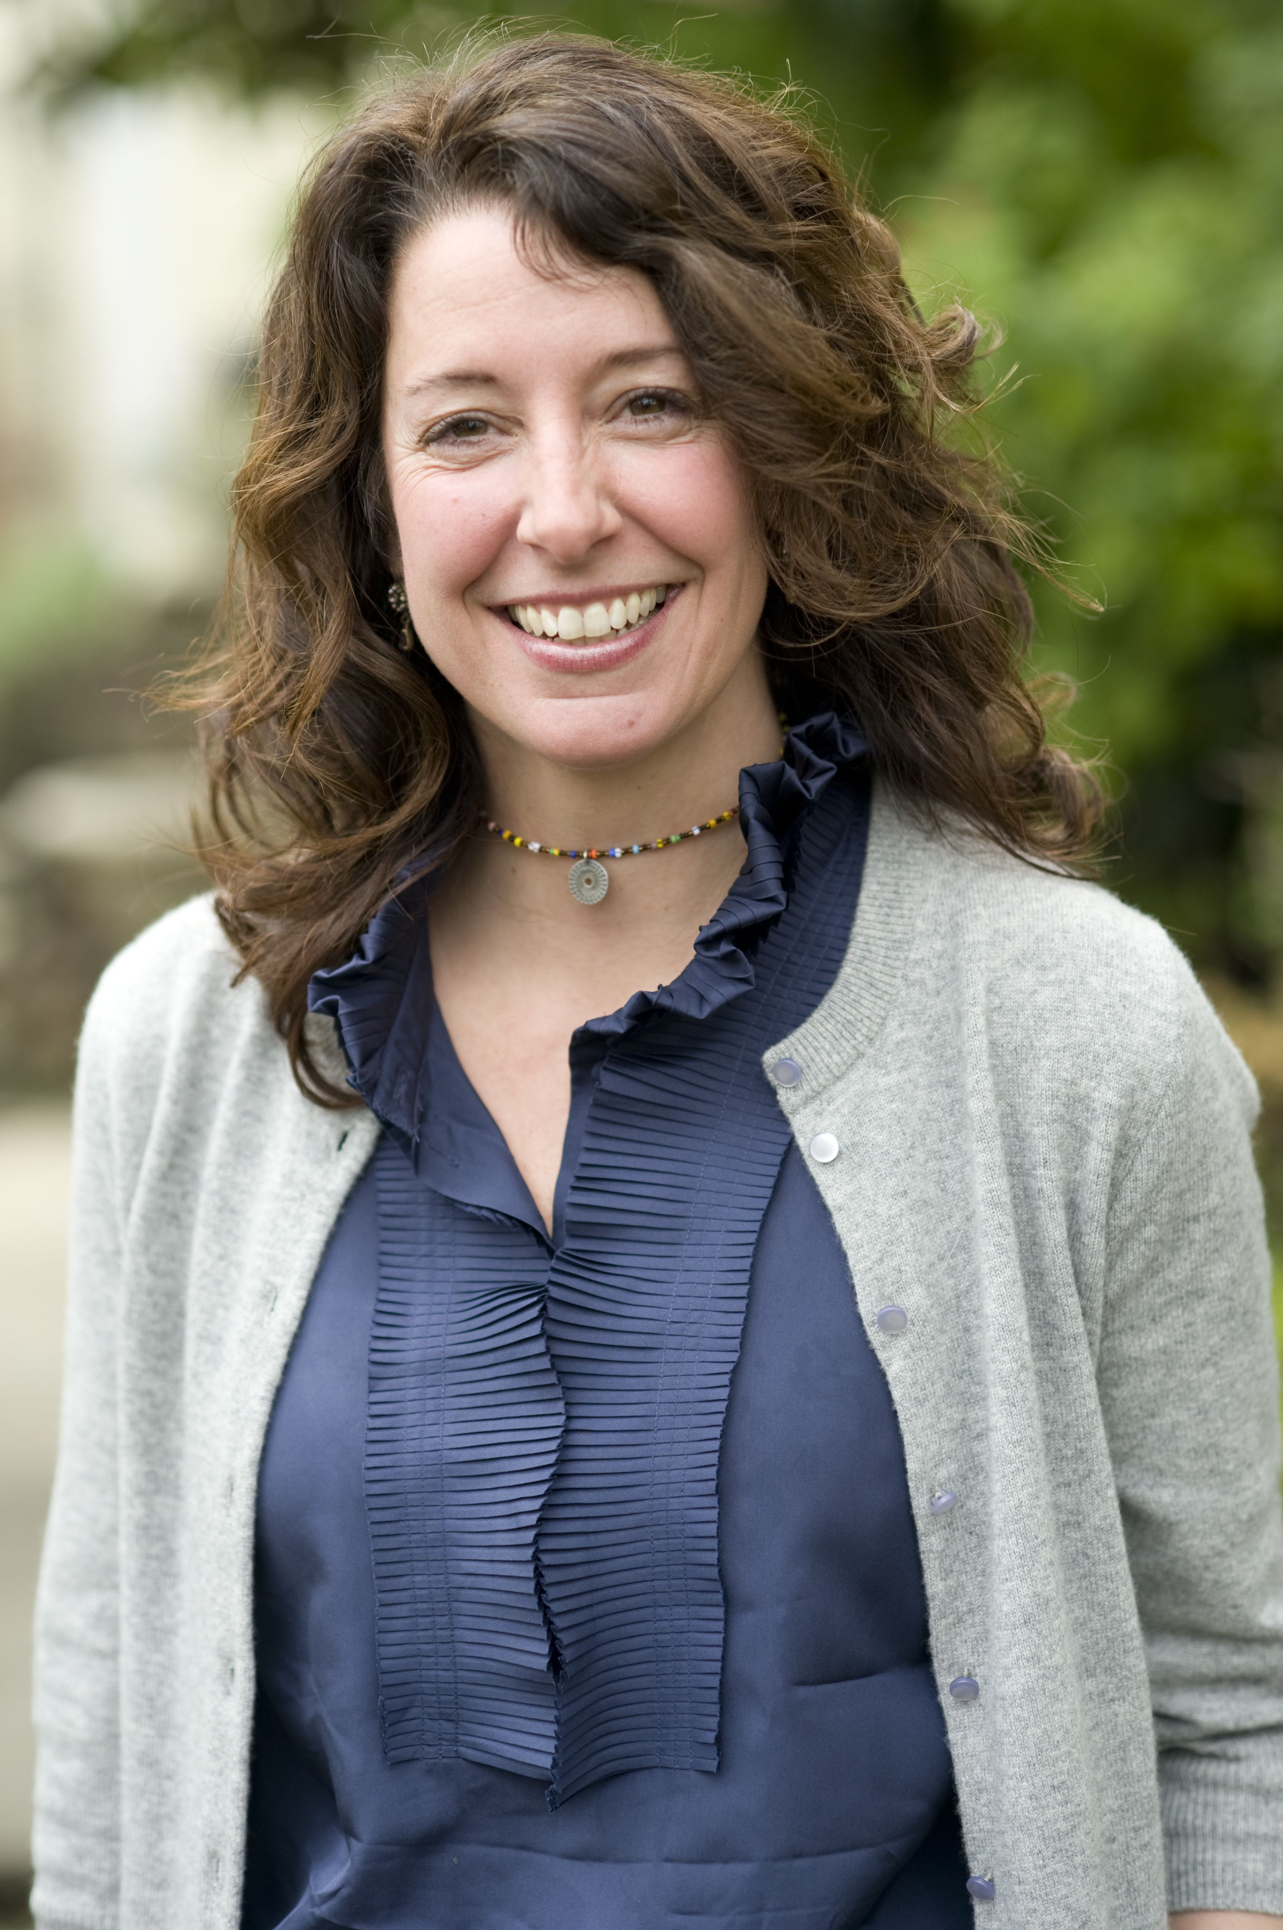
Kate Roeske is a leadership coach and trainer who brings 20 years experience to her coaching, training and consulting work. She works with Fortune 500 companies and non-profits providing inspirational and action-oriented coaching and training. As a professional trainer Kate has designed and presented leadership development and team-building programs for Mozilla, CBS interactive, Davita, Microsoft, Ogilvy & Mather, Leo Burnett, United Way, and others. Kate has worked throughout the U.S. as well as in the U.K., Dubai and South Africa.

Kate’s unique style is highly collaborative in every aspect of her work – from the upfront planning stage through the delivery of executive coaching and training. She finds the right solution for each client so their specific needs are met. Kate specializes in working with teams and individuals to increase their leadership skills, including cultivating emotional intelligence, understanding what reactive behaviors might be in the way and how to create a shared approach to problem solving. She is certified in The Leadership Circle a transformational 360 that leads to sustainable results in individuals and the teams they lead.

Kate is passionate about coaching individuals towards the life they are truly wanting to live. This includes work-life balance, finding the values that are important to them and living by them and stepping into what they know.

Kate worked for ten years as an Account and Planning Director, Senior Partner at Ogilvy & Mather advertising agency. Her primary focus was on strategic development for Fortune 500 companies, which has given her a deep understanding of the issues that leaders, teams and individuals in corporate environments face. She worked on a host of brands including as Dove, United Way and Kodak.

Kate is on the faculty of The Coaches Training Institute, a worldwide training organization that trains individuals to become professional coaches. She is also on the faculty of PCI, another worldwide corporate organization that brings the skills of coaching and communication into the corporate world. She has a PCC (Professional Certified Coach) qualification from the International Coaching Federation. Kate is also a speaker at the 2012 Association of Change Management Professionals Global Conference in Las Vegas.

Kate has a B.A. from Stephens College in Columbia, MO. and a M.A. from Cambridge University in England and is a certified co-active coach and completed Leadership Training both through The Coaches Training Institute. She can be reached at Kateroeske@me.com.

Finally, Kate cannot believe she gets to live the life she does! She is living in Boulder Colorado with her husband and two grown up step-daughters and gets to play in the foothills with her dog Baxter. She believes that dreams really do come true and her life is proof of that.

